1. report upload
2. view report

2.1 selection of the type of graphics

1. to download the report click  on “RECEPT REPORTS"

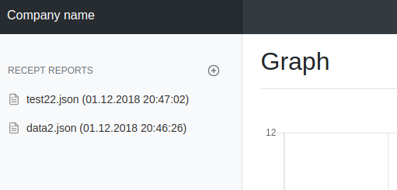

1.2. On the page that open, select .json file from your pc and click Upload

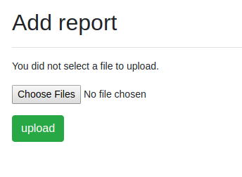

after successful uploading, this file will appear in the “RECEPT REPORTS” list.

2.1 to display the report - click on report file in the list menu “RECEPT REPORTS”.

2.2 If need, you can change the type of the displayed chart by selecting its type in the upper right corner of the page.

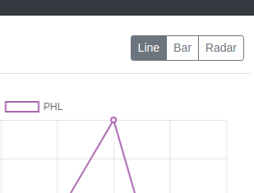

2.3 If need to display a graph for individual data, remove the extra elements by clicking on the line names.

